Wonder Valley is an English medium, co-educational learning community in southern Thailand. We seek to create a holistic learning environment that nurtures each child’s individual talent and intelligence, as well as their physical, emotional and spiritual well-being. Through inquiry and experiential learning, we inspire children to discover what it is they love to do and where their full potential lies.

Although Wonder Valley is not committed to a particular approach to education per se, our visions have been inspired by the questions raised by Jiddu Krishnamurti, who felt that the true purpose of education is self-understanding, without which all of man’s technological advancement and intellectual prowess will only bring about more suffering and destruction. This is perhaps even more acute at this time in human history, where digital technology is increasingly taking over various areas of our daily life.

Natural aesthetics are essential for a child’s well-being. Thus, open skies, perennial streams, clean air, water and wholesome food form an integral part of our community. Our 25-acre campus is nestled in a beautiful valley in Thung Lung, 20 kilometers from Hat Yai, the business center of southern Thailand, by the border with Malaysia.

Currently we operate as a homeschool and we are applying to register as an international school by 2022. Starting from Kindergarten, then opening Grade 1 in 2022, we plan to add another class each year as our students grow.

Wonder Valley is directed by Soonya Vanichkor, alumni of Rishi Valley and Brockwood Park Schools. Here she is sharing the story and the vision behind Wonder Valley.

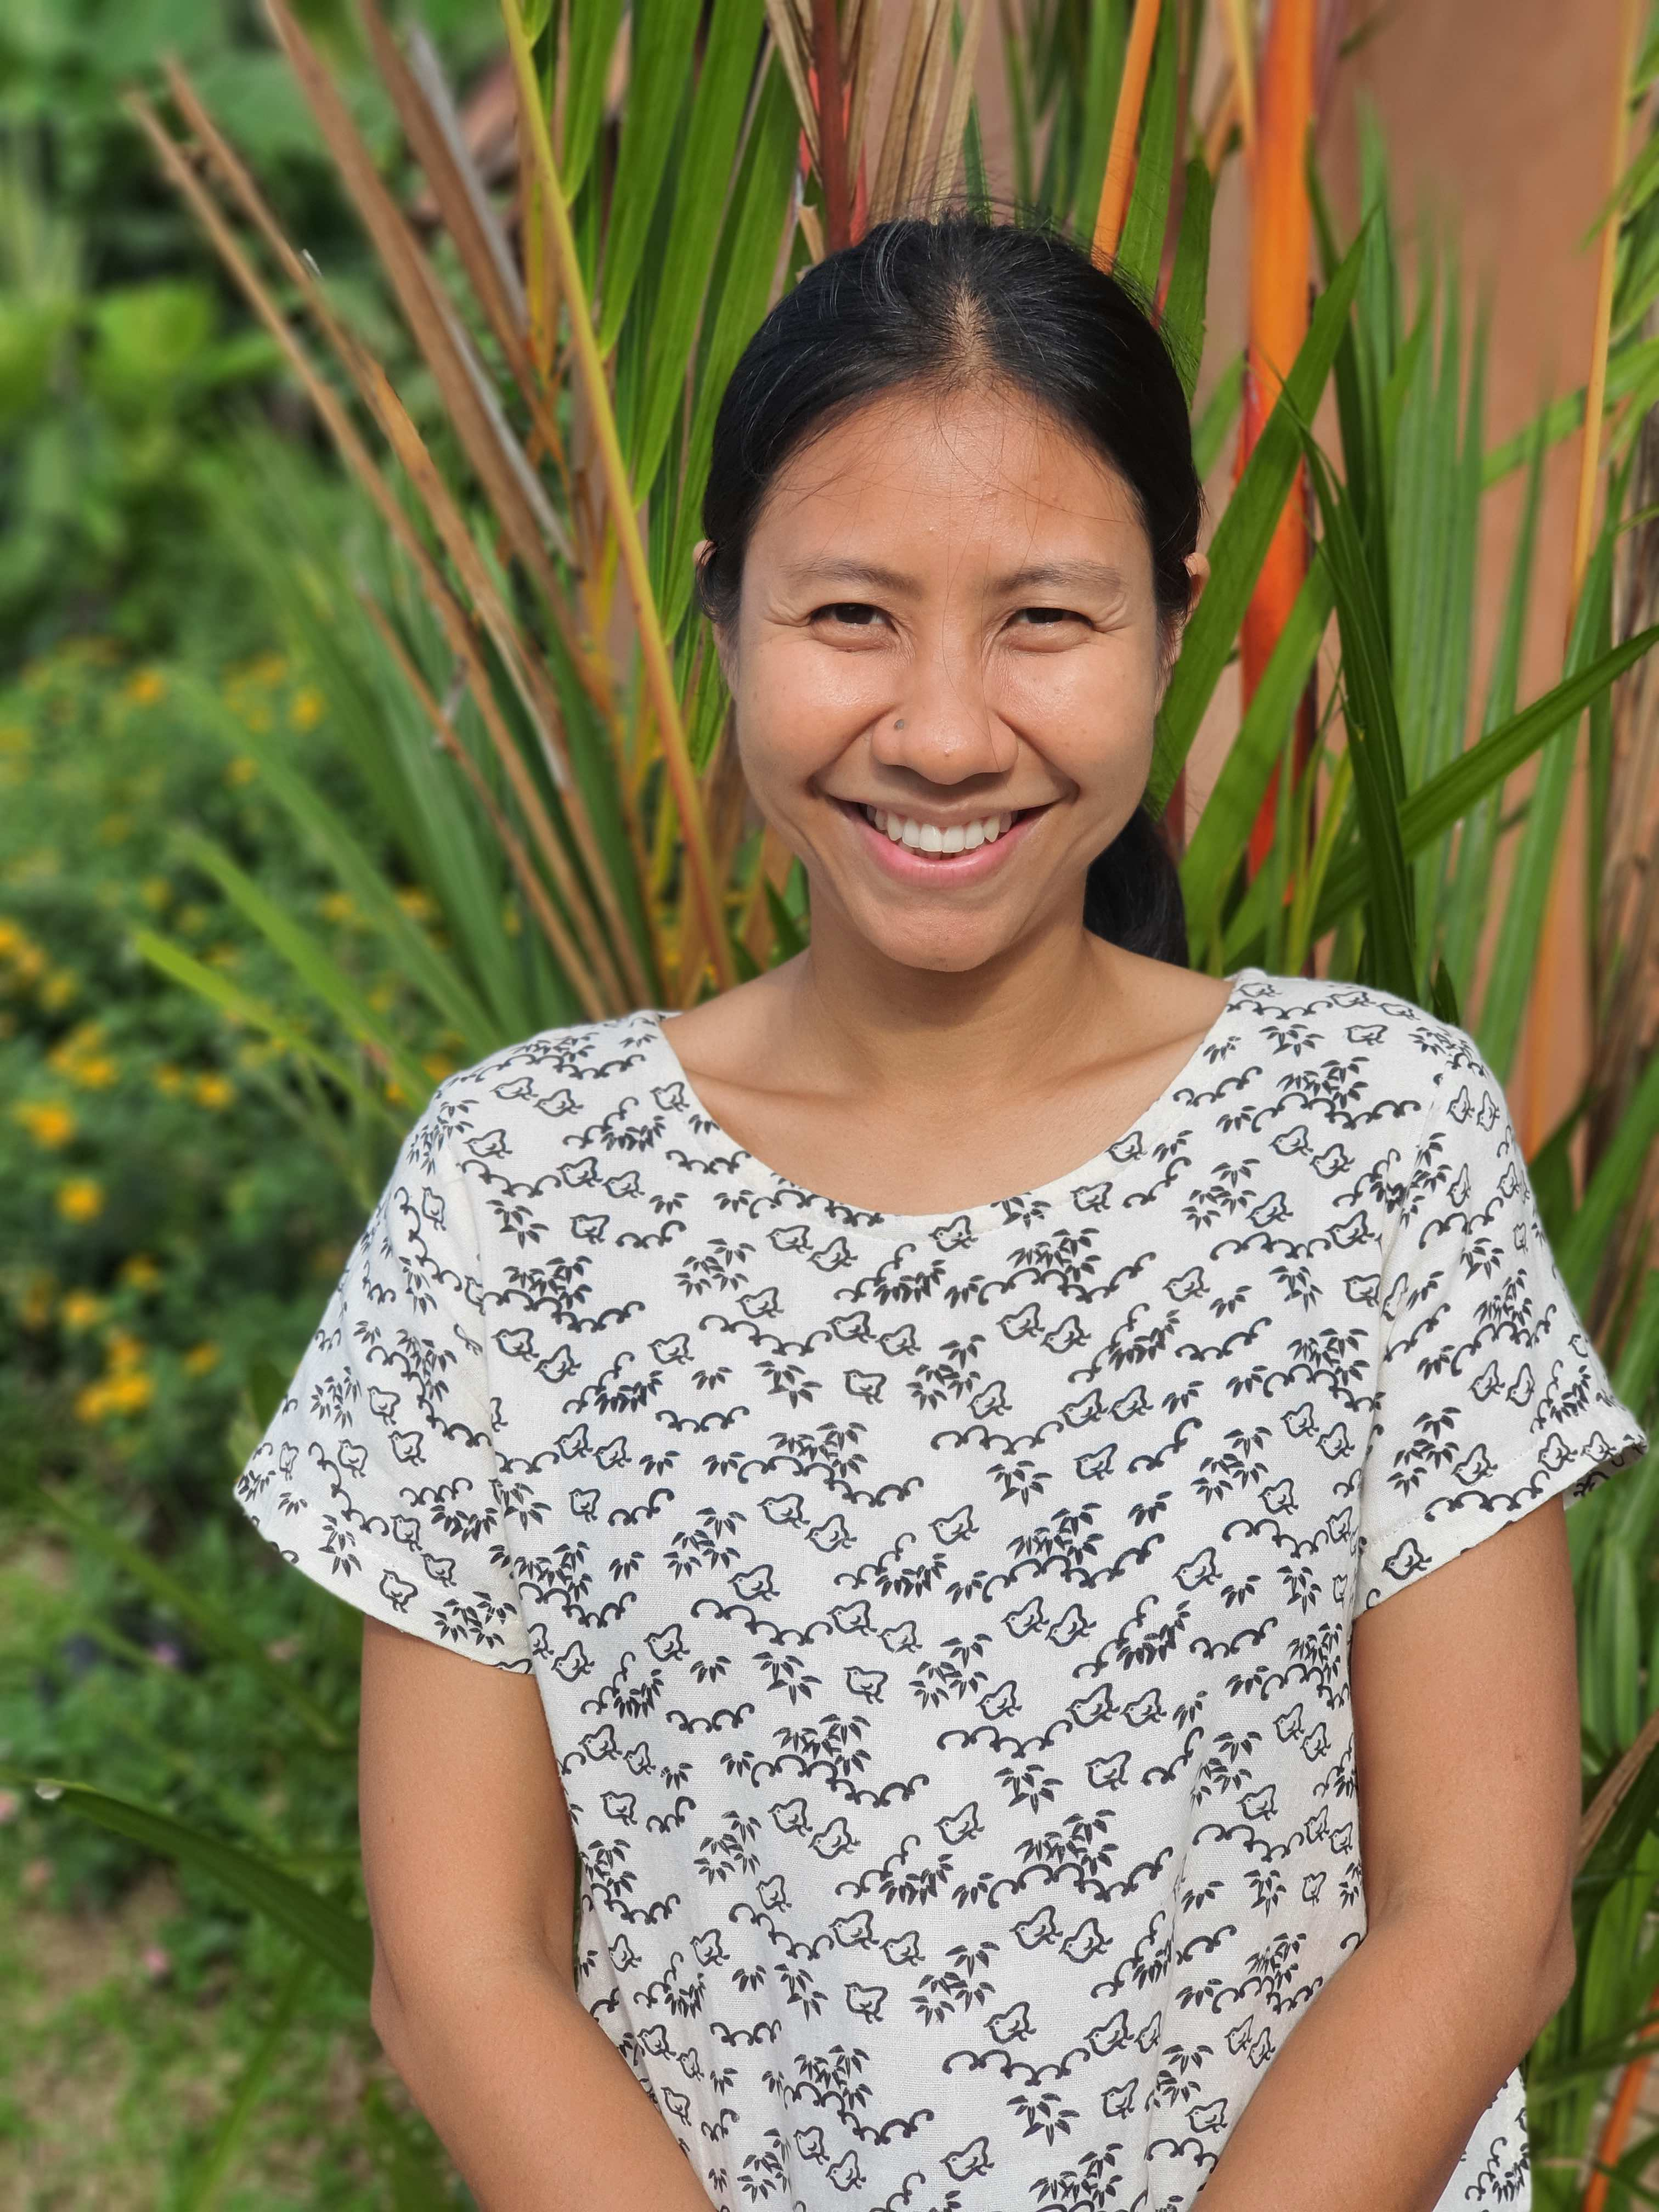

"Twenty-five years ago, there was an initiative to start a holistic school called The Orchid Hill in Thung Lung, near Hat Yai. However, at that time, the educational climate in southern Thailand was not progressive enough for such an endeavor to take shape and the proposal was put on hold. In the hope that the younger Thai generation passionate about education would resume the project, over the years land for the school campus had been gradually procured. And so, in 2021, the holistic school project was brought back to life.
It appears that the only way to tackle the current problems in today's society is to begin with education. Educating young children to seek clarity, to seek a wholesome life. Based on Soonya's own personal journey of understanding her own inner landscape, the mission (or vision?) of the school unfolded clearly: to nurture children in an atmosphere of freedom and compassion, so that they will be able to learn both about the external world, as well as their inner world, their relationship to life, their values, believes and ideas. Wonder Valley will be a school where teachers value children for who they are as opposed to who they should be, thus encouraging children to discover their own true potential.

