2023 Mürren International Gathering
around the work of
J. KRISHNAMURTI

Saturday 24 June – Saturday 8 July

Please note earlier dates, necessary to keep costs down

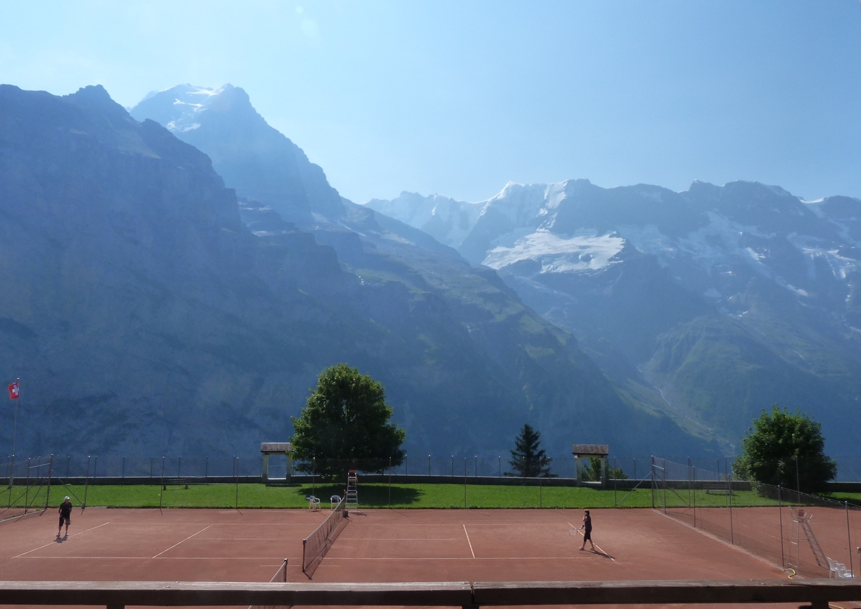
Mürren (alt. 1650m), above Lauterbrunnen Valley
near Interlaken, Switzerland
Mürren is a car-free mountain village with beautiful walks
overlooking the Eiger, Mönch and Jungfrau

The gathering takes place at hotel Sportchalet
Join for one or two weeks
If you require a shorter stay, please book other accomodation in Mürren
You will still share all activities and meals in Sportchalet

Information: Claire Dufour – claratolo@gmail.com
Themes and full programme available beginning of 2023

“The important thing is to discover, and after discovering, to keep going.”

ACTIVITIES
Viewing and reflecting on selected talks of J. Krishnamurti
Questioning and participating in dialogues
Gentle exercises proposed by participants
Hiking in beautiful mountains
Free time

An atmosphere of friendliness, seriousness and silence
contributes to the quality of inquiry.
There is no authority and no goal to reach.

CHF 600* per person per week, with shared bathrooms on each floor
Full board (light lunch). Free entrance to the SportCentre swimming pool
* Plus CHF 100 per week for the overall organisation, due also from those staying elsewhere

~ Please book with Claire by end-March 2023 ~

Check ch.ch (5 languages) for requirements on entering Switzerland
We recommend you have a European Health Insurance Card or travel insurance
Mürren or Mürren BLM stations can be reached by cableway and train only
For schedules, go to sbb.ch (4 languages)
Sportchalet Mürren is a few minutes’ walk between the two stations

